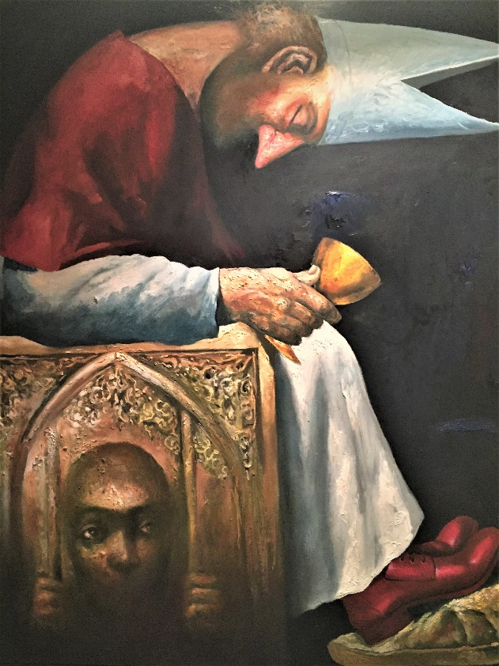

*Emmanuel “Manny” Garibay*

“Trono”, 2014.

Oil on canvas.

38” X 38”

“Trono” is Tagalog for “Throne”